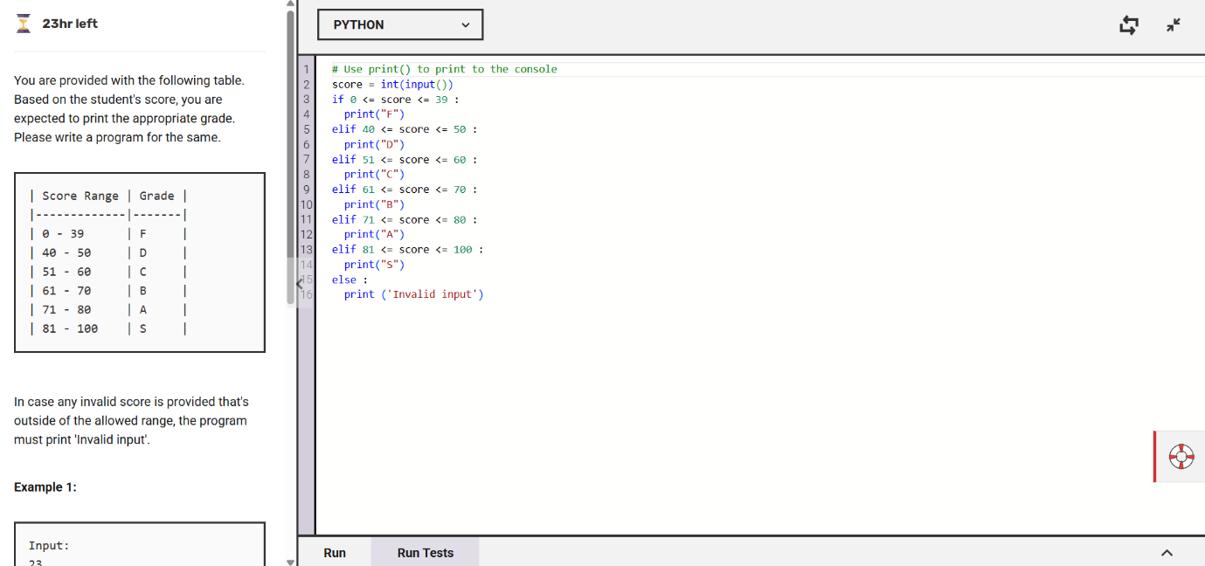
The image shows a Python program that assigns grades based on a student's score using conditional statements. If the score is outside 0-100, it prints Invalid input.

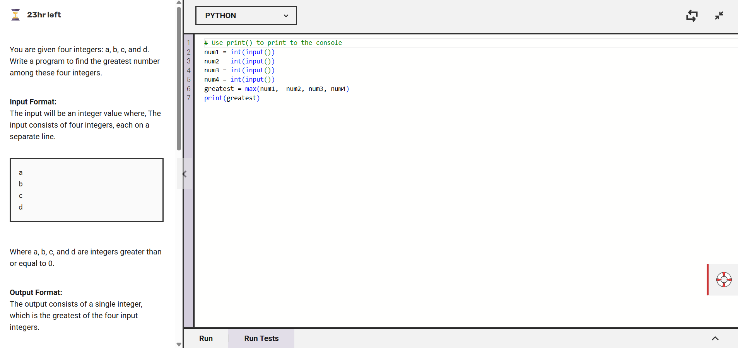

The image shows a Python program that finds the greatest number among four given integers using the max() function. The program takes four inputs, converts them to integers, and prints the largest one.

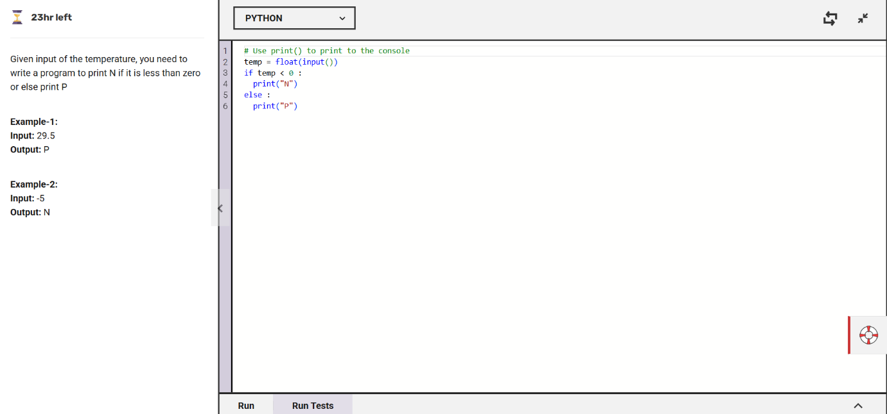

The image shows a Python program that checks if a given temperature is below zero. If it is, it prints N; otherwise, it prints P.

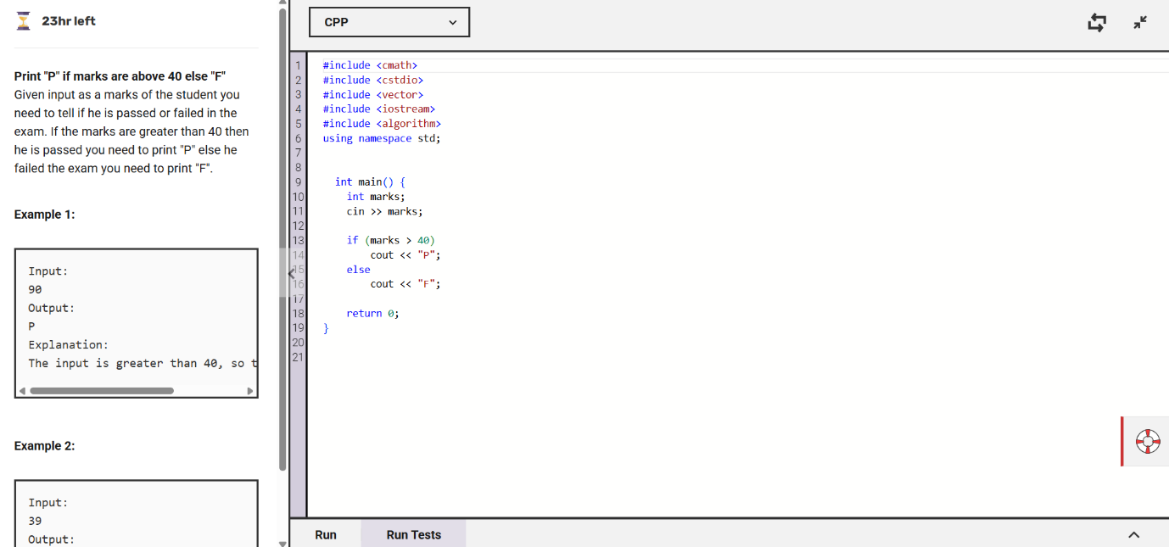

The image shows a C++ program that checks if a student's marks are above 40. If they are, it prints P for pass; otherwise, it prints F for fail.

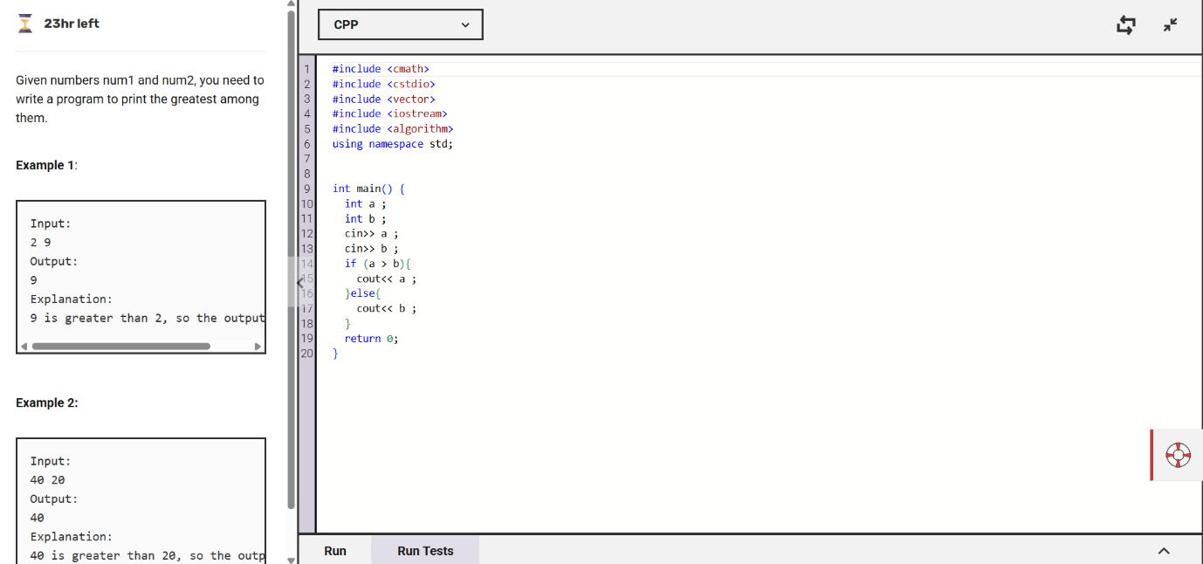

The image shows a C++ program that takes two numbers as input and prints the greater one. It uses an if-else condition to compare the numbers and display the largest.

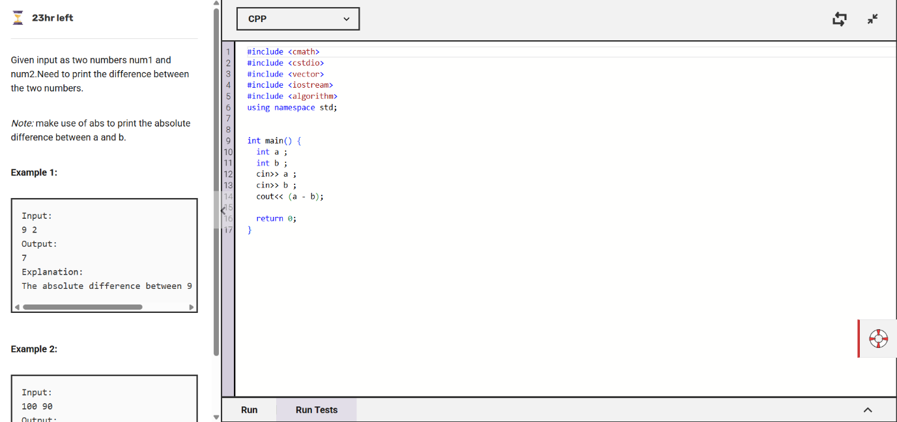

The image shows a C++ program that takes two numbers as input and prints their absolute difference. It uses the abs() function to ensure the result is always positive.

